A Machine Learning-Based Decision Support Platform for Smart Farming
Ch. Surya (2420090001), V. Rithwik (2420090037), P. Akshya (roll no. to be added), B. Niharika (2420030601), and K. Swanthana (Faculty)
Department of Computer Science and Engineering
Koneru Lakshmaiah Education Foundation, Bowrampet, Hyderabad-500043, Telangana, India
Emails: [author email addresses to be added]
Abstract—Most farming decisions, such as which crop to sow, when to irrigate and how to deal with a diseased plant, still rest on experience and manual observation, even though soil, weather and plant health keep changing. In this paper we describe a web-based decision-support platform that uses machine learning for four tasks: crop recommendation, leaf-disease classification, irrigation-need estimation and crop-yield forecasting. The platform takes soil nutrient and climate readings as well as leaf photographs, and it screens out non-plant and blurry images before they reach the classifier. We compared Decision Tree, Random Forest, Support Vector Machine, XGBoost and LightGBM models using accuracy, precision, recall, F1-score, mean absolute error, root mean square error and R². On the 22-class crop recommendation task, Random Forest was the most accurate at 99.55%, with LightGBM and XGBoost both at 99.09%. On the 32-class leaf-disease task, Random Forest again led with 97.81%. For the regression tasks, XGBoost had the smallest errors: 1.65 mm for irrigation and 1.35 quintals per acre for yield. The system is built with React, FastAPI and PostgreSQL, works in English, Telugu and Hindi, and passed all 42 of its automated end-to-end and integration tests. We also point out what the results do not show: sensor readings were simulated, the datasets are curated rather than collected in the field, and recommendations should be checked with local agricultural experts before anyone acts on them.
Keywords—smart farming, precision agriculture, machine learning, crop recommendation, plant disease classification, irrigation estimation, yield forecasting, Random Forest, XGBoost.

I. INTRODUCTION
Farming depends on many things at once: soil fertility, rainfall, temperature, humidity, water supply, crop variety and the health of the plants themselves. Choosing a crop, deciding when to irrigate and reacting to the first signs of disease all affect yield and how much water and fertilizer are used. Checking fields by eye still has real value, but it takes time, it is hard to repeat across large areas, and many small farmers have little access to an agronomist when they need one.
Machine learning (ML) can pick up patterns from past agricultural records and apply them to new cases, and image classification can recognise symptoms that show on a leaf. Earlier studies have looked at ML for crop recommendation and farm management [1]–[3]. In most of them, though, crop choice, disease identification, irrigation planning and yield estimation are handled as separate problems with separate tools and data.
We built a web platform that puts these tasks in one place for the farmer, while keeping the data, models and evaluation for each task separate. Our contributions are as follows. First, a modular design covering four prediction tasks, along with fertilizer, weather and market-price services. Second, a side-by-side comparison of five classical ML algorithms under one evaluation protocol. Third, image filters that reject non-plant and blurry photographs before disease classification. Fourth, access in English, Telugu and Hindi. Fifth, a testing record that clearly separates verified results from simulated parts of the system.
II. RELATED WORK
Supervised learning has been used on soil and climate variables to suggest suitable crops. One crop recommendation system for Indian agriculture draws on soil, climate and related data to support crop selection [1], and another study applies ML methods to crop selection as environmental conditions change [3]. Other work places ML inside smart farm management, including data-driven crop management and resource allocation [2]. Taken together, these studies give a good reason to compare several algorithms rather than settle on one early.
For plant health, the PlantVillage collection of labelled leaf images [5] is widely used to train and test disease classifiers. Ensemble tree methods such as Random Forest [6] and boosting libraries such as XGBoost [7] and LightGBM [8] are common choices for tabular prediction. For irrigation, the FAO-56 guidelines [9] set out the standard way to compute crop evapotranspiration and crop water requirements, which gives an irrigation module a sound physical basis.
One problem comes up again and again: datasets differ in crops, regions, collection methods and labels. A model trained on one of them cannot simply be assumed to work in another region or on a real farm. For this reason we evaluate each task on its own and say clearly what each result covers.
III. SYSTEM ARCHITECTURE
A. Technology stack
The frontend uses React 18 with Vite. The backend is a FastAPI service running on Uvicorn, with a PostgreSQL 15 database behind it. Model training and inference rely on Scikit-Learn, XGBoost and LightGBM. Users log in with JSON Web Tokens signed with HS256, passwords are stored as Bcrypt hashes, and role-based access control (RBAC) keeps administrative endpoints away from ordinary accounts.
Fig. 1 gives an overview. A request travels from the web interface to the FastAPI layer, which authenticates the user and checks the inputs, and then on to the ML module for that task. The database and the supporting services sit alongside.
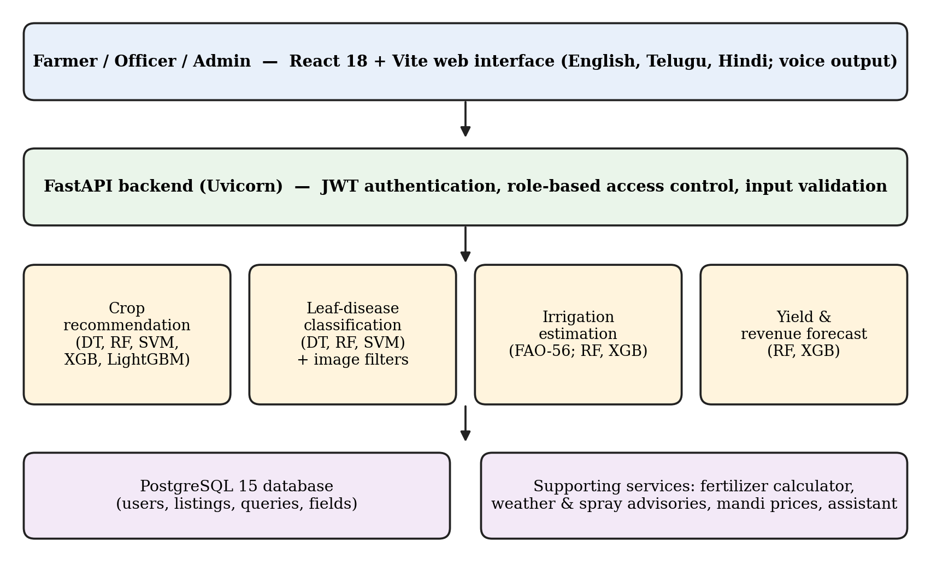
Fig. 1. Architecture of the proposed platform.
B. Functional modules
The prediction layer is made up of four independent modules. The crop module predicts a crop from nitrogen, phosphorus and potassium (NPK), soil pH, temperature, humidity and rainfall. The disease module classifies an uploaded leaf image as healthy or as one of the disease classes, and returns a confidence value along with remedies in three languages. The irrigation module follows the FAO-56 approach to work out the soil-moisture deficit and the net water requirement, in millimetres and in litres per acre, and also assigns an urgency class. The yield module predicts yield in quintals per acre and an estimated gross revenue in Indian rupees.
Around these modules are several supporting services. A fertilizer calculator turns NPK soil deficits into doses of Urea, DAP, MOP and micronutrients in kilograms per acre. There is a 5-day weather and spray-advisory service, APMC mandi price listings with short price trends, a marketplace where farmers can list produce, and a ticket system in which farmers send queries that officers review and resolve. A multilingual assistant answers agronomy questions in English, Telugu and Hindi, and responses can be read aloud through the browser speech-synthesis interface.
C. Image validation
Every uploaded image goes through two checks before classification. A vegetation-ratio filter rejects images where the share of plant-coloured pixels is below 0.08, and the request then fails with an HTTP 400 error. A Laplacian edge-variance filter picks out blurry images. Without these checks, the classifier could return a confident disease label for a photo that is not a leaf at all.
IV. MATERIALS AND METHODS
A. Datasets
For crop recommendation we used a public Crop Recommendation dataset [4] containing 2,200 records and 22 crop classes. Its input features are N, P, K, temperature, humidity, pH and rainfall. For disease classification we used a 32-class leaf-image collection derived from PlantVillage-type data [5]. The irrigation and yield modules were trained and tested on our own project datasets, because independent field-measured irrigation and yield records were not available to us.
B. Preprocessing and model training
The system checks units and ranges on every input and rejects missing or out-of-range values, rather than returning a misleading recommendation. Scaling is applied only where an algorithm needs it, such as the SVM, and its parameters are fitted on the training data alone so that nothing leaks from the test set. Within each task, all models share the same split and feature set, which keeps the comparison fair. The split between training and test data was [state split ratio and random seed]. Five algorithms were trained for crop recommendation: Decision Tree, Random Forest, SVM, XGBoost and LightGBM. Disease classification used Decision Tree, Random Forest and SVM, and the irrigation and yield tasks used Random Forest and XGBoost regressors.
C. Evaluation metrics
For classification we report accuracy, precision, recall and F1-score, the last being the harmonic mean of precision and recall. Precision, recall and F1 are weighted averages across classes. For regression we report mean absolute error (MAE), root mean square error (RMSE) and the coefficient of determination (R²). In the irrigation task, accuracy means assigning the correct urgency class. In the yield task, accuracy is the share of predictions that fall within 15% of the true value. This tolerance-based measure is specific to our work, so it should not be compared directly with classification accuracy. We also recorded the inference time for a single prediction.
V. RESULTS AND DISCUSSION
A. Crop recommendation
Table I shows how the five algorithms did on the 22-class crop task. Random Forest was the most accurate at 99.55%. LightGBM and XGBoost followed at 99.09%, the Decision Tree reached 98.64%, and the SVM came last at 97.95%. The gap between best and worst is under two percentage points, which suggests the seven input features separate the crop classes quite cleanly. Every model was fast, with inference times from 0.02 ms (Decision Tree) to 0.12 ms (Random Forest), so speed does not drive the choice here. As a simple functional check, the input N = 90, P = 42 and K = 43 gave Rice, with a 95% score from Random Forest and 99% confidence from LightGBM.
TABLE I. CROP RECOMMENDATION RESULTS (22 CLASSES, 2,200 RECORDS)
Algorithm | Acc. (%) | Prec. (%) | Rec. (%) | F1 (%)
Random Forest | 99.55 | 99.60 | 99.55 | 99.56
LightGBM | 99.09 | 99.18 | 99.09 | 99.10
XGBoost | 99.09 | 99.15 | 99.09 | 99.09
Decision Tree | 98.64 | 98.74 | 98.64 | 98.66
SVM | 97.95 | 98.14 | 97.95 | 97.98

B. Leaf-disease classification
Table II covers the 32-class disease task. Random Forest reached 97.81% accuracy, the SVM 96.88% and the Decision Tree 94.27%. The gap of about 3.5 points between the Decision Tree and Random Forest shows how much ensembling helps on a problem with this many classes. All three models responded in under 0.15 ms. A caution is needed here: curated images differ from field photographs in lighting, background and camera quality, so these numbers describe performance on the dataset and not accuracy in the field. We leave a per-class confusion analysis for future work.
TABLE II. LEAF-DISEASE CLASSIFICATION RESULTS (32 CLASSES)
Algorithm | Acc. (%) | Prec. (%) | Rec. (%) | F1 (%)
Random Forest | 97.81 | 97.85 | 97.81 | 97.82
SVM | 96.88 | 96.94 | 96.88 | 96.89
Decision Tree | 94.27 | 94.35 | 94.27 | 94.29

C. Irrigation and yield estimation
The regression results are in Table III. For irrigation, XGBoost did better than Random Forest, with an MAE of 1.65 mm against 1.82 mm, an RMSE of 2.48 mm against 2.64 mm, and an R² of 0.982 against 0.978. Yield followed the same pattern: XGBoost reached an MAE of 1.35 quintals per acre and an R² of 0.948, while Random Forest gave 1.42 and 0.941. The two models are close, so interpretability and deployment cost could reasonably decide between them.
These two tasks need a careful reading. The irrigation module is built around FAO-56 relationships, so a high R² shows that the model reproduces that formulation. It does not show that the model predicts water need measured independently in the field. In the same way, the yield results come from project datasets and not from outcomes recorded on farms. Both modules need to be validated against field-measured data before the figures can be read as real-world accuracy.
TABLE III. IRRIGATION AND YIELD REGRESSION RESULTS
Task / Model | Acc. (%) | MAE | RMSE | R²
Irrigation – RF | 96.40 | 1.82 | 2.64 | 0.978
Irrigation – XGB | 96.80 | 1.65 | 2.48 | 0.982
Yield – RF | 94.20 | 1.42 | 2.15 | 0.941
Yield – XGB | 94.80 | 1.35 | 2.08 | 0.948
MAE and RMSE are in mm for irrigation and quintals per acre for yield. Yield accuracy is the share of predictions within 15% of the true value.
D. System testing
We tested the platform with 42 automated scenarios, 11 end-to-end and 31 integration tests. They covered API contracts, database operations, RBAC, the ML pipelines, image validation, the multilingual assistant and the market-price service. All 42 passed once the problems below were fixed, and the TypeScript production build finished with no compiler errors. Testing turned up five defects: a missing property in a TypeScript user type; a console encoding error when printing Telugu and Hindi text on Windows; a missing weather endpoint; a field-sensor endpoint that used an undefined model and a wrong attribute name; and a marketplace schema that rejected requests using alternative field names. We traced each one to its cause and fixed it. Access control also behaved as intended: a farmer account asking for administrator statistics received HTTP 403.
VI. LIMITATIONS
Some parts of the system were never tested with real inputs. No physical soil sensors were connected, so the dashboard readings come from a microclimate simulation. The external Gemini language-model service was not switched on, and the assistant ran on the built-in offline knowledge model. Payment processing for the marketplace has not been implemented. The disease dataset consists of curated images, and the irrigation and yield labels do not come from independent field trials. Performance may drop for crops, regions, seasons and soils that are thinly represented in the training data. The yield accuracy measure is also non-standard, so it should be read together with MAE, RMSE and R². The system is meant to support decisions, not replace agronomists or field testing, and its advice should be checked against local guidance before it affects crop or water management.
VII. CONCLUSION AND FUTURE WORK
We presented a modular ML platform that supports crop recommendation, leaf-disease classification, irrigation estimation and yield forecasting through a multilingual web application. Random Forest gave the best results for crop recommendation (99.55%) and disease classification (97.81%), while XGBoost gave the lowest errors for irrigation and yield. The platform passed all 42 automated tests, and we have stated its limitations openly.
Several steps come next. We plan to connect live IoT soil sensors, validate the irrigation and yield models on field-collected data, and test the disease classifier on real field photographs with a per-class confusion analysis. We also want to add explainable predictions, switch on the external language-model service, and run field trials with agricultural experts and farmers.
CONFLICT OF INTEREST
The author(s) declare(s) that there is no conflict of interest regarding the publication of this paper.
ACKNOWLEDGMENT
The authors thank the Department of Computer Science and Engineering, Koneru Lakshmaiah Education Foundation, for its support. [Add funding or grant details, if any.]
REFERENCES
[1] “Leveraging Artificial Intelligence and Machine Learning for Enhanced Crop Yield: A Crop Recommendation System for Indian Agriculture,” in Proc. 2023 Int. Conf. IoT, Communication and Automation Technology (ICICAT), 2023, doi: 10.1109/ICICAT57735.2023.10263734.
[2] “Smart Farm Management Using Machine Learning,” in Proc. 2024 Int. Conf. IoT, Communication and Automation Technology (ICICAT), 2024, doi: 10.1109/ICICAT62666.2024.10923013.
[3] “Agriculture Crop Recommendation System Using Machine Learning,” in Proc. 2024 Int. Conf. Advancements in Smart, Secure and Intelligent Computing (ASSIC), 2024, doi: 10.1109/ASSIC60049.2024.10507899.
[4] THUDM, “Crop Recommendation Dataset,” Hugging Face Datasets. [Online]. Available: https://huggingface.co/datasets/THUDM/Crop_recommendation. Accessed: Oct. 29, 2026.
[5] D. P. Hughes and M. Salathé, “An open access repository of images on plant health to enable the development of mobile disease diagnostics,” arXiv:1511.08060, 2015.
[6] L. Breiman, “Random forests,” Machine Learning, vol. 45, no. 1, pp. 5–32, 2001.
[7] T. Chen and C. Guestrin, “XGBoost: A scalable tree boosting system,” in Proc. 22nd ACM SIGKDD Int. Conf. Knowledge Discovery and Data Mining, 2016, pp. 785–794.
[8] G. Ke et al., “LightGBM: A highly efficient gradient boosting decision tree,” in Advances in Neural Information Processing Systems 30, 2017, pp. 3146–3154.
[9] R. G. Allen, L. S. Pereira, D. Raes, and M. Smith, “Crop evapotranspiration—Guidelines for computing crop water requirements,” FAO Irrigation and Drainage Paper 56, Food and Agriculture Organization, Rome, 1998.

